**AuthenticMaterials Assignment**

|  |  |
| --- | --- |
| **Names:** | **Astashina Aleksandra, Zubkov Ivan** |

|  |  |
| --- | --- |
| **Level:** | **upper-intermediate** |
| **Source of authentic material:** | [**How the humble coconut is starting to fuel parts of Papua New Guinea | Pacific islands | The Guardian**](https://www.theguardian.com/world/article/2024/may/10/png-coconut-tree-oil-copra-biodiesel)(cut-off version of the text) |

**Please note that you must use full sentences in the template. The assignment must be written in continuous prose.**

**Part 1** (200 words).

|  |  |
| --- | --- |
| 1. Describe your potential educational context: What **level** is this text for? For a **group for an individual lesson**? Student **age**? Needs? | This text is for upper-intermediate students and is for use in a group lesson. The text is designed for 16-18 years old students (high school). The needs of the students are the following:   * to get used to read longer texts using skimming and scanning techniques; * to learn quickly skim the text for understanding   the main idea (gist);   * to learn to find the necessary specific/detailed information by scanning the text; * to develop communicative skills; * to improve group/pair working skills; * to learn to think critically. |
| 2. Explain why you have selected this material for this particular group/student:   * Why do you think this text is appropriate for your group/student? (refer to their **level, text type/genre** and **length**) * Why would the text you have chosen **interest** your learner/group of learners? * How would specific learners’ **needs** in **skills** development be catered for in this lesson? | * In our opinion, the text is appropriate for a group of upper-intermediate students since we believe these students possess a basic understanding of environmental science and sustainability concepts. The text type is informative, blending elements of a case study and an article, which allows students to engage with real-world applications of theoretical knowledge. Its length is manageable, providing enough details to stimulate discussion without overwhelming students. * This text will generate interest for our students, because the topic of renewable energy is increasingly significant in today's context of climate change and sustainability. Students may find it engaging to learn about innovative solutions being implemented in real communities. * To address specific learners’ needs in skills development during this lesson, the following strategies will be employed:  1. **Debates:** Students are encouraged to analyze the economic implications of using coconut biodiesel versus traditional fuels and discuss their ideas with each other. 2. **Collaborative learning:** group discussions are organized where students propose their own ideas for sustainable energy solutions in their communities fostering collaboration, creativity and critical thinking. 3. **Presentation Skills:** As a follow-up activity, students could present their findings on coconut biodiesel or other renewable energy sources, helping them develop public speaking and presentation abilities. 4. **Skimming and scanning skills:** Students are provided with the gist task aiming at understanding of the general idea of the text as well as with the specific/detailed information task targeting at finding some particular information in the text. |

**Part 2** (800 words)

|  |  |
| --- | --- |
| **1. How** would you **generate interest** in the topic of the text? **Why** is this important? | To generate interest in the topic of the text, we will:   1. **start with the personalized task:** begin by discussing the significance of coconuts in the students' lives or communities. Ask questions like, "How many of you have used coconut products?" or "What do you know about the role of coconuts in our local economy?" This helps students connect personally to the subject matter. 2. **use visual aids:** using visuals of Karkar Island, coconut trees, and the biodiesel production process. Short videos showing the impact of biodiesel on local communities can also be powerful in capturing attention and illustrating real-world applications.   Generating interest in the topic is crucial for **engagement and motivation** (when students are interested in a subject, they are more likely to engage actively with the material, participate in discussions, and retain information). This intrinsic motivation can lead to deeper learning experiences **and critical thinking** (an engaging introduction to the topic encourages students to ask questions, think critically about solutions to energy challenges, and consider their roles in promoting sustainability). |
| 2. What **pre-reading/pre-listening** activities will you do to prepare your learners for your text? Which items of vocabulary from the text would you **pre-teach** and **why**? (*Not* how!) | As for the pre-reading tasks, we would like to introduce some activities that generate the interest starting with personalized task and **K-W-L Chart:**  What I Know: asking students to fill out the "K" section of a K-W-L chart (Know, Want to know, Learned) about coconuts, biodiesel, and renewable energy. This helps activate prior knowledge and sets a purpose for reading. Encouraging students to list questions they have about the topic, which can guide their focus during the text.  In our opinion, there are no concrete vocabulary items which could hinder the understanding of the material and completing of the tasks. That is why we believe that we do not need to pre-teach any words or phrases for this text. |
| 3. **Design** and describe the first reading/listening task, stating the target sub-skill (gist or specific information). Attach any materials (e.g., handouts with your questions and the text) you would distribute (and include an answer key). Explain clearly **how the task will help your learners practise the target sub-skill**. Describe the **feedback** you would do. | The first task is the Gist task:  **Task 1:** What do you know about the role of coconuts on Karkar Island?  **Expected answer:** Key Answer (with text support):  Coconuts are used to produce biodiesel for local energy needs.  **Explanation:** Paragraph 1 introduces the shift from old to new use. "Now, the island is putting coconuts to another use."  Paragraph 2 explicitly states the new purpose (fuel production) and its applications: "The oil from copra [...] is used to produce biodiesel [...] powering schools, hospitals, and cargo ships."  Paragraph 4: Lists vehicles/ships powered by the fuel (ambulances, police cars, etc.).  **Another possible answer:** Coconuts were a lucrative export.  **Explanation:** Paragraph 1 states "Decades ago, coconuts were a lucrative export, but [...] they have become less prized on international markets."  The objective of this task is to develop students' ability to identify the main idea of the text quickly by skimming the text and trying to understand its overall (general) idea without scanning the text for any specific details. Though there is a potential key answer in the 1, 2, 4 paragraphs, this task does not suppose any specific formulation of the answers, and all answers that are relevant for the current question and correspond to the main idea of the text are appropriate.  After completing this task I would ask students if someone wants to share his ideas about this task and praise them for the successful completion of the task. If nobody revealed the gist of the text, I would pay students’ attention to the second paragraph which contains the targeted answer and be ready to listen to other answers if they appeared during the process of the discussion of the task. Then I will ask students to move on to Task 2. |
| 4. **Design** and describe the second reading/listening task, stating the target sub-skill (specific info or detail). Attach any materials (e.g., handouts with your questions and the text) you would distribute (and include an answer key). Explain clearly **how the task will help your learners practise the target sub-skill**. Describe the **feedback** you would do. | The second task is the combination of detailed and specific information tasks since it includes both the questions that need specific answers as well as questions that need detailed answers.  **Task 2:**  1. How much coconut biodiesel is produced annually on Karkar Island?  2. What were coconuts originally used for on Karkar Island?  3. How is biofuel produced?  4. Which other countries are mentioned as developing similar biodiesel projects?  5. Where the biodiesel is produced?  6. What are the challenges in expanding the coconut biodiesel project?  **Answers:**  1. **Expected answer**: 600,000 litres of coconut-based biodiesel are produced annually on Karkar Island.  **Explanation:** Derek Middleton states this figure in Paragraph 3: "says they produce 600,000 litres of coconut-based biofuel each year."  2. **Expected answer:** Coconuts were originally used as a lucrative export, but their value declined over time on international markets.  **Explanation:** Paragraph 1 mentions coconuts were once "a lucrative export" but lost value on international markets.  3. **Expected answer:** Biofuel is produced by shredding high-quality copra, squeezing out the oil, and mixing it with lye and alcohol in a chemical process to create biodiesel.  **Explanation:** Paragraph 8 describes the process of producing the biofuel: "shredding high-quality copra, squeezing out the oil, and mixing it with lye and alcohol."  4. **Expected answer:** Vanuatu and Fiji.  **Explanation:** Paragraph 5 notes "Other Pacific countries, including Vanuatu and Fiji, have developed similar small-scale projects."  5. **Expected answer:** The biodiesel is produced at Kulili Plantation on Karkar Island.  **Explanation:** Paragraph 3 introduces Kulili Plantation as the production site.  6. **Expected answer:** Expanding the project is securing backing and funding to grow the operation.  **Explanation:** Paragraph 7 states "securing backing to grow the operation has proved challenging," and Paragraph 12 adds the need for "more funding.  This task involves scanning of the text with the aim of finding specific answers (as is the case with Task 1, 2, 4, 5) as well as searching for more detailed answers (as is the case with Task 3, 5). The objective of this task is to develop the ability of finding particular answers to the questions on the basis of the text.  After completing the task I would ask students to share their answers and ask them to state their opinion by indicating the appropriate answer in the relevant paragraph. As this task supposes specific and detailed answers, there would not be a lot of variation in the answers. This fact will help to understand the correctness of completion of the task by students and clarify the unclear cases if there are any. After that I will ask students to move on to Task 3. |
| 5. **Design** and describe the follow-up production task (speaking or writing) – attach any materials (handouts) you would distribute. Explain **how this task will help your learners practise the target skill** (not language). Describe how you would **set** the activity and how you would organize **feedback**. | The third task is the production speaking task which aims at practicing students’ speaking skills based on the information they have learned from the text. This collaboration task encourages students to exchange their ideas with each other and practice their communicative skills.  **Task 3:**  In pairs discuss whether the use of biodiesel could be a viable solution for other regions. What are the pros and cons of switching to biofuels?  I will not give any templates here since it is the speaking task and I want students to communicate freely and share their ideas instead of following the particular structure. The templates may invoke the loss of interest and will discourage students from brainstorming their ideas. Instead of this I will just pay students’ attention to the fact that they can use some ideas from the text if they want, but I will not restrict their choice in this task and just ask them to keep in mind the gist of the discussed text. After the discussion in pairs I will listen to all of the students’ ideas and clarify whether this idea is appropriate to the current question. If there are no ideas, I will introduce some possible answers on this question and indicate the paragraphs where the necessary information is contained and be ready to listen to students if they have new ideas.  **Possible answers:**  Some viable solution for other regions:  1. Reduces fuel imports  Text evidence: "The fuel has replaced diesel in many instances" (Paragraph 5) and "would reduce dependence on costly fuel imports" (Paragraph 7).  Argument: Regions reliant on imported fuel (e.g., islands, remote areas) could save money.  2. Uses local resources  Text evidence: Coconuts were previously undervalued but now power local infrastructure (Paragraphs 1–2).  Argument: Other regions could repurpose existing crops (e.g., palm oil, soy) for biodiesel.  3. Environmentally friendly  Text evidence: "Biodiesel is a more environmentally friendly fuel" (Paragraph 8).  Argument: Lowers carbon emissions compared to fossil fuels.  4. No engine modifications needed  Text evidence: It can be "used alone or blended with traditional fuels without modifying engines" (Paragraph 9).  Argument: Easy to adopt with existing vehicles/machinery.  5. Creates local jobs  Text evidence: Economist Laveil mentions "potential for more employment" (Paragraph 12).  Argument: Boosts rural economies through farming and production.  **Pros** of switching to biofuels**:**  Cheaper alternative to imports (Paragraph 6: "reducing dependence on costly fuel imports").  Environmentally friendly (Paragraph 8: "a more environmentally friendly fuel").  No engine modifications needed (Paragraph 9: "used alone or blended with traditional fuels without modifying engines").  **Cons** of switching to biofuels**:**  Funding challenges (Paragraph 7/12: difficulty securing investment).  Limited scalability (Paragraph 12: relies on local coconut supply; expansion requires training). |

Our handout is presented below on the next page.

**Handout (Astashina, Zubkov).**

Level of students**: upper-intermediate.**

**Task 1:**

Look at the questions below and discuss them in pairs:

1. Have you ever used any coconut products? What were these products?
2. What do you know about the role of coconuts in the world economy?

**Task 2:**

What are some common renewable sources of energy? Complete a mind map.

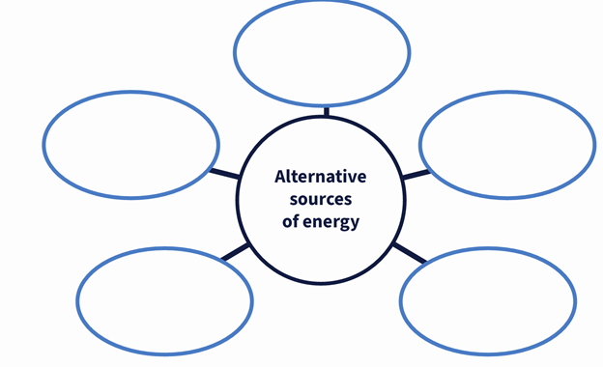

**Coconut Biodiesel Offers a Cheaper Alternative to Fuel Imports.**

On Karkar Island in Papua New Guinea, hundreds of coconut trees stretch far into the distance. Decades ago, coconuts were a lucrative export, but over the years, they have become less prized on international markets. Now, the island is putting coconuts to another use.

The oil from copra – the white flesh of the coconut – is used to produce biodiesel, a renewable fuel made from biological sources, such as vegetable oils or animal fats. On Karkar, the fuel is helping to power schools, hospitals, and cargo ships.

The biodiesel is produced at Kulili Plantation, which spans roughly 980 hectares filled with coconut trees and cocoa plants. Derek Middleton, the Managing Director at Kulili, says they produce 600,000 litres of coconut-based biofuel each year. The project began in 2007, when Kulili developed a small facility to produce coconut biodiesel. Over time, it has proved successful, and Middleton is working to expand the project.

“The fuel is used on Karkar in government vehicles, ambulances, police cars, motor vehicles, ships, generators, and our own business,” says Middleton.

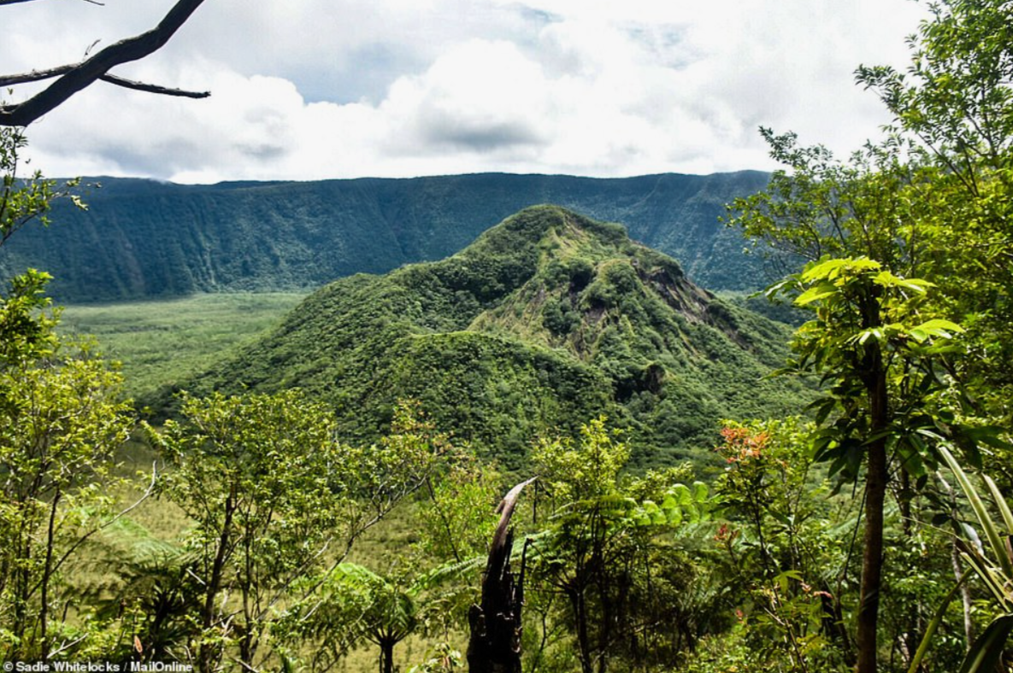

Other Pacific countries, including Vanuatu and Fiji, have developed similar small-scale projects and researched using coconut biodiesel as an alternative to traditional fuels like diesel. On Karkar, the fuel has replaced diesel in many instances and is sold cheaply to the island’s people.

The country’s leading science institute, PNG University of Technology (Unitech), is researching how coconut biodiesel could be used more widely, particularly in rural and remote communities in Madang Province, where Karkar is located.

Middleton says expanding the local industry would reduce dependence on costly fuel imports, but securing backing to grow the operation has proved challenging. Economist Maholopa Laveil states that with profitable and sustainable investments, development partners may be needed, and “the positive social impact would be undeniable.”

Turning coconut into biodiesel has a history in Papua New Guinea. In addition to Madang, it was used by revolutionary forces in Bougainville during the 1980s and 1990s crisis. The process involves breaking down coconut oil by shredding high-quality copra, squeezing out the oil, and mixing it with lye and alcohol in a chemical process to create biofuel. When used alone, biodiesel is a more environmentally friendly fuel.

“It’s just diesel, but instead of using crude oil, we use coconut oil,” says Middleton, adding that it can be used alone or blended with traditional fuels without modifying engines.

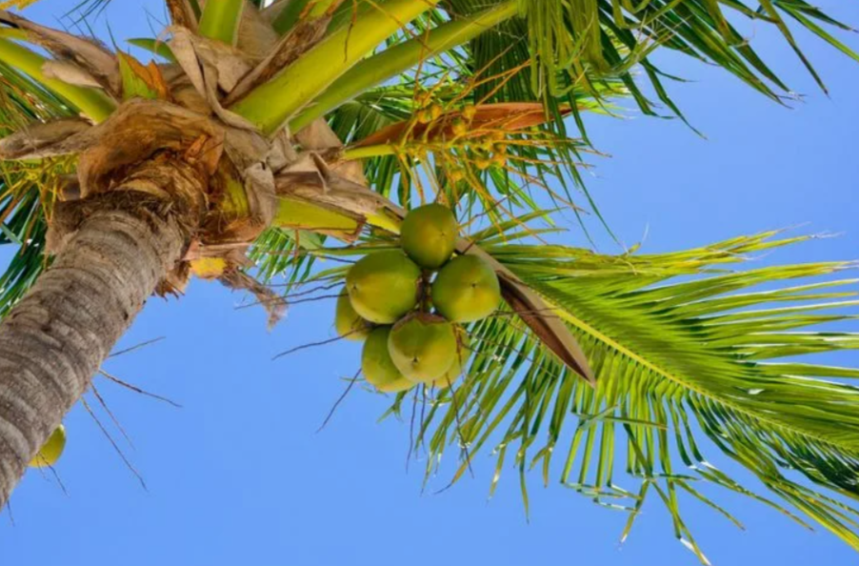

Biodiesel has replaced about 50,000 litres of fuel each month, but 25,000 litres of traditional fuel is still imported. Currently, all coconuts are sourced from Kulili. The plantations have been owned by the Australian-PNG Middleton family since the 1920s. Cocoa is the main export product, with a focus on growing the coconut biofuel operation.

Middleton believes that with more funding, the project could supply the rest of Madang Province, home to about 500,000 people. Kulili has approached the Madang government about expanding the project, with some interest shown.

Laveil says developing biofuels could benefit the region, offering the potential for more employment, provided there are training opportunities. He sees the Kulili project as a model for the region, contributing to the transition to green energy.

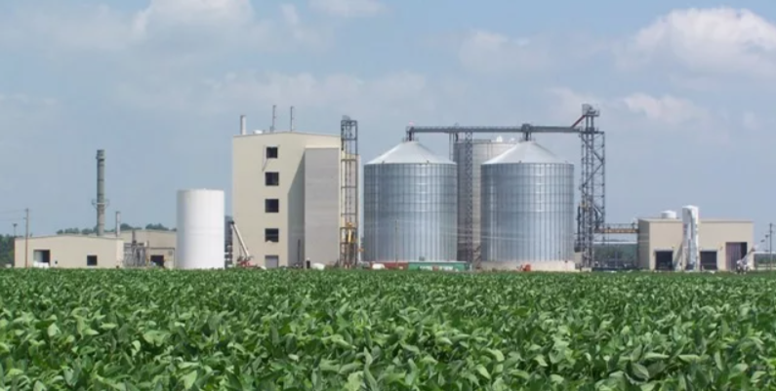

**Task 3:**

What do you know about the role of coconuts on Karkar Island?

**Task 4:**

1. How much coconut biodiesel is produced annually on Karkar Island?

2. What were coconuts originally used for on Karkar Island?

3. How is biofuel produced?

4. Which other countries are mentioned as developing similar biodiesel projects?

5. Where the biodiesel is produced?

6. What are the challenges in expanding the coconut biodiesel project?

**Task 5:**

In pairs discuss whether the use of biodiesel could be a viable solution for other regions. What are the pros and cons of switching to biofuels?

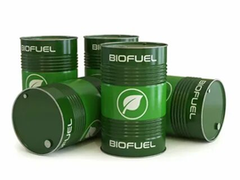

Answers to **Tasks**:

Task 1:

**Possible answers** for question 1:

1. "Yes, I’ve tried coconut water and coconut milk in curries”
2. "I love Bounty chocolate bars—they have coconut filling!"
3. "My shampoo contains coconut oil—it makes hair softer."
4. "I use coconut oil as a natural skin moisturizer."
5. "Only coconut flavor in desserts, but not real coconut."

**Possible answers** for question 2:

1. "Countries like Indonesia, the Philippines, and India grow a lot of coconuts."
2. "Coconut exports are vital for tropical island economies."
3. "Coconut oil is used globally for cooking and cosmetics."
4. "Demand for coconut water and vegan products is growing."
5. "I’m not sure, but I guess coconuts are important for tropical countries’ income."

Task 2:

**Possible answers:**

1. Solar Energy (photovoltaic panels, solar power plants)
2. Wind Energy (onshore and offshore wind turbines)
3. Hydropower (large hydroelectric dams, small hydro, tidal and wave power)
4. Biomass (wood, biogas, bioethanol)
5. Geothermal Energy (Earth’s heat for heating and electricity)
6. Hydrogen (green hydrogen produced from renewables)
7. Ocean Energy (OTEC – thermal gradients, marine currents)
8. Biofuels (biodiesel, ethanol for transport)
9. Alternative Hydropower (micro-hydro systems without dams)
10. Hybrid Systems (solar-wind, solar-diesel combinations).

Task 3:

**Expected answer:** Key Answer (with text support):

Coconuts are used to produce biodiesel for local energy needs.

**Explanation:** Paragraph 1 introduces the shift from old to new use. "Now, the island is putting coconuts to another use."

Paragraph 2 explicitly states the new purpose (fuel production) and its applications: "The oil from copra [...] is used to produce biodiesel [...] powering schools, hospitals, and cargo ships."

Paragraph 4: Lists vehicles/ships powered by the fuel (ambulances, police cars, etc.).

**Another possible answer:** Coconuts were a lucrative export.

**Explanation:** Paragraph 1 states "Decades ago, coconuts were a lucrative export, but [...] they have become less prized on international markets."

Task 4:

1. **Expected answer**: 600,000 litres of coconut-based biodiesel are produced annually on Karkar Island.

**Explanation:** Derek Middleton states this figure in Paragraph 3: "says they produce 600,000 litres of coconut-based biofuel each year."

2. **Expected answer:** Coconuts were originally used as a lucrative export, but their value declined over time on international markets.

**Explanation:** Paragraph 1 mentions coconuts were once "a lucrative export" but lost value on international markets.

3. **Expected answer:** Biofuel is produced by shredding high-quality copra, squeezing out the oil, and mixing it with lye and alcohol in a chemical process to create biodiesel.

**Explanation:** Paragraph 8 describes the process of producing the biofuel: "shredding high-quality copra, squeezing out the oil, and mixing it with lye and alcohol."

4. **Expected answer:** Vanuatu and Fiji.

**Explanation:** Paragraph 5 notes "Other Pacific countries, including Vanuatu and Fiji, have developed similar small-scale projects."

5. **Expected answer:** The biodiesel is produced at Kulili Plantation on Karkar Island.

**Explanation:** Paragraph 3 introduces Kulili Plantation as the production site.

6. **Expected answer:** Expanding the project is securing backing and funding to grow the operation.

**Explanation:** Paragraph 7 states "securing backing to grow the operation has proved challenging," and Paragraph 12 adds the need for "more funding.

Task 5:

**Possible answers:**

Some viable solution for other regions:

1. Reduces fuel imports

Text evidence: "The fuel has replaced diesel in many instances" (Paragraph 5) and "would reduce dependence on costly fuel imports" (Paragraph 7).

Argument: Regions reliant on imported fuel (e.g., islands, remote areas) could save money.

2. Uses local resources

Text evidence: Coconuts were previously undervalued but now power local infrastructure (Paragraphs 1–2).

Argument: Other regions could repurpose existing crops (e.g., palm oil, soy) for biodiesel.

3. Environmentally friendly

Text evidence: "Biodiesel is a more environmentally friendly fuel" (Paragraph 8).

Argument: Lowers carbon emissions compared to fossil fuels.

4. No engine modifications needed

Text evidence: It can be "used alone or blended with traditional fuels without modifying engines" (Paragraph 9).

Argument: Easy to adopt with existing vehicles/machinery.

5. Creates local jobs

Text evidence: Economist Laveil mentions "potential for more employment" (Paragraph 12).

Argument: Boosts rural economies through farming and production.

**Pros** of switching to biofuels**:**

Cheaper alternative to imports (Paragraph 6: "reducing dependence on costly fuel imports").

Environmentally friendly (Paragraph 8: "a more environmentally friendly fuel").

No engine modifications needed (Paragraph 9: "used alone or blended with traditional fuels without modifying engines").

**Cons** of switching to biofuels**:**

Funding challenges (Paragraph 7/12: difficulty securing investment).

Limited scalability (Paragraph 12: relies on local coconut supply; expansion requires training).